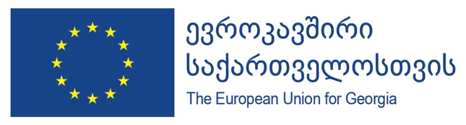

European Union and WHO deliver critical supplies for COVID-19 frontline health workers in Georgia
24 July 2020, Tbilisi
A shipment of medical respirators, masks, goggles, face shields and gowns to enable health-care workers in Georgia to continue to respond effectively and safely to the COVID-19 pandemic arrived in the country this week.
The delivery of up to 1.5 million pieces of personal protective equipment, funded by the European Union and procured by WHO, includes 5,000 faceshields, 13,200 protective goggles, 30,000 isolation gowns, 1,000,000 medical masks and 328,000 respirator masks.
This is one of the largest cargos of protective equipment to arrive in Georgia with donor support. These supplies will safeguard those in the frontlines of the COVID-19 response, and ensure that the health system is well prepared in case of additional needs in the near future.
All items of equipment delivered have been checked to ensure they meet quality and safety standards for health-care workers on the frontline. Lugar Center for Public Health Research, 9 regional labs of National Center for Disease Control, Emergency Situations Coordination and Urgent Medical Assistance Center with 4,200 crew members of ambulances and village doctors across Georgia will receive personal protective equipment.
Vincent Rey, Head of Cooperation at the Delegation of the European Union to Georgia, and Silviu Domente, WHO Representative in Georgia, handed over the equipment to the Ministry of Internally Displaced Persons from the Occupied Territories, Labour, Health and Social Affairs of Georgia.
“The EU, as part of Team Europe, continues to stand by Georgia in combatting the COVID-19 crisis. This medical equipment delivery is one of the largest provided by any donor and will further strengthen Georgia’s medical capacities and protect front line workers throughout the country, both today and for possible developments in the future. It’s a part of our wider package supporting vulnerable groups and economic recovery and a further indication of our strong partnership with Georgia,” Mr. Rey noted.
“In the fight against the pandemic, the support of both the European Union and WHO is crucial. This 15 tons of cargo is one of the largest contributions that Georgia has received during this difficult period. This assistance is of strategic importance and is intended to protect health of doctors and medical staff who make a vital contribution to the fight against coronavirus. It is for their commitment that Georgia stands where it does today and is one of the most successful examples of fighting the virus. Of course, this would have not been so easy without the help from our strategic partners,” – says Ekaterine Tikaradze, Minsiter of Internally Displaced Persons from the Occupied Territories, Labour, Health and Social Affairs of Georgia.
Silviu Domente, said: “Health-care workers are at the frontline of our response to COVID-19, which is placing them at higher risk of exposure to the virus. They are our heroes, but they are not superhuman. This protective equipment delivered, thanks to the generous contribution of the European Union, will reduce the risks they face in their daily work and will help protect them and their patients alike” he added.
The donation of the personal protective equipment with WHO is part of the European Union’s response to the outbreak of COVID-19 in Georgia. Further medical based support, implemented with WHO, will include training for health-care workers and frontline responders and a strengthening the health sector’s overall preparedness and response capacities.
This assistance is part of a wider package of EU support for Georgia of over €400 million (almost GEL 1.5 billion) which includes support to vulnerable groups and economic recovery. In total, the EU has committed over €15 billion globally to support partner countries combat COVID-19.
Source of information for journalists:
- Stay updated via the interactive dashboards on the latest COVID-19 statistics WHO HQ; WHO/Europe; these provide real-time, in-depth information on the situation.
- Please visit the WHO website for COVID-19 advice for public
- Information on the European Union in Georgia is available at https://eeas.europa.eu/delegations/georgia_en
For further information, contact:
Tamriko Mikadze, Delegation of the European Union to Georgia | Tamriko.Mikadze@eeas.europa.eu
Tamila Zardiashvili, WHO | zardiashvilit@who.int

